**Middle East North America Health**

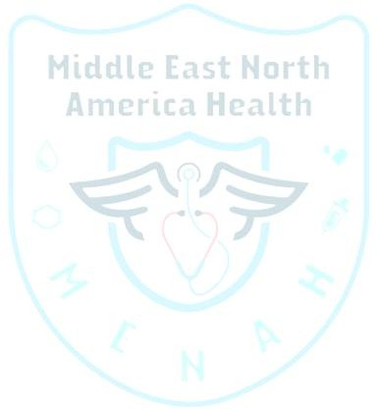**Non-Disclosure Agreement (NDA)**

**This Agreement is made on [ 17 / 4/ 2025] between:**

1. **Disclosing Party:** MENAH Inc. LTD, RN: 1677280-3, Lindenwood, Winnipeg, Manitoba, R3P2R2, Canada.

# Receiving Party: [ ]

residing at [Cairo] City, [Egypt] country.

# Purpose

The Receiving Party agrees to maintain strict confidentiality regarding all projects, information, and materials related to MENAH Inc. LTD, including but not limited to

proprietary data, business strategies, and client information. This Agreement aims to prevent unauthorized disclosure, misuse, or dissemination of Confidential Information in any form. **Confidential Information**

Confidential Information includes, but is not limited to:

* + Written, electronic, audio, or video records.
  + Text messages, emails, and social media communications.
  + Oral information, whether official or non-official, private or public, personal or professional.
  + Business plans, customer lists, financial information, project details, proprietary data, and any ideas, concepts, or discussions shared by the Disclosing Party.
  + Any information that could reasonably be considered confidential, regardless of its format or medium.

# Obligations of the Receiving Party

The Receiving Party agrees to:

# Strict Confidentiality:

**Middle East North America Health**

* + Keep all Confidential Information in strict confidence and not disclose it to any third parties without prior written consent from the Disclosing Party.

# Prohibited Actions:

* + Avoid discussing, sharing, or referencing Confidential Information in any form, including but not limited to:
    - Text messages, emails, or instant messaging platforms.
    - Social media posts, comments, or private messages.
    - Casual conversations with friends, family, or acquaintances.

# Purpose Limitation:

* + Use the Confidential Information solely for the purpose of fulfilling their role at MENAH Inc. LTD.

# Reasonable Measures:

* + Implement reasonable measures to safeguard Confidential Information, including secure storage, restricted access, and adherence to company policies.
  + Attend mandatory training sessions on confidentiality protocols provided by MENAH Inc. LTD.

# Accountability for Breaches:

* + Acknowledge that breaches of confidentiality due to ignorance, unawareness, or failure to take reasonable measures to protect Confidential Information will be considered a disclosure and treated as a material breach of this Agreement.

# Exclusions

Confidential Information does not include information that:

# Publicly Available:

* + Is publicly available without breach of this Agreement.

# Prior Knowledge:

* + Was known to the Receiving Party prior to disclosure, provided that such

knowledge is substantiated by documented legal evidence submitted prior to signing this Agreement. Acceptable evidence includes:

# Middle East North America Health

* + - Written documentation through MENAH Inc. LTD's official platform.
    - Signed governmental documents verifying prior knowledge.

# Legal Disclosure:

* + Is required to be disclosed by law, provided the Receiving Party notifies the Disclosing Party in advance through written documentation.

# Breach and Remedies

In the event of a breach of this Agreement, the Receiving Party acknowledges that:

* The Disclosing Party may seek injunctive relief, damages, or other legal remedies.
* Any unauthorized disclosure, whether intentional or accidental, will be considered a material breach of this Agreement.

# Term and Termination

This Agreement shall commence on the Effective Date and remain in effect for the duration of the Receiving Party's employment. The confidentiality obligations shall survive termination of this Agreement indefinitely.

# Governing Law

This Agreement shall be governed by and construed in accordance with the laws of Manitoba, Canada.

# Signatures

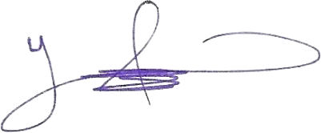

**Disclosing Party**: Yahya Ethawi, Chair, and founder, MENAH Inc. LTD, RN: 1677280-3, Lindenwood, Winnipeg, Manitoba, R3P2R2, Canada.

**Date**: 12 April 2025

# Middle East North America Health

**Receiving Party**: (Full official Name in English as in the passport), mobile, email and

address, please provide a copy of a governmental ID with photo such as passport or national ID)

Signature: Youssef Soltan

**Name**: Youssef Soltan **Date**:17/4/2025

**Address**: New Cairo, 90th street

**Email**: y_soltan@gmail.com

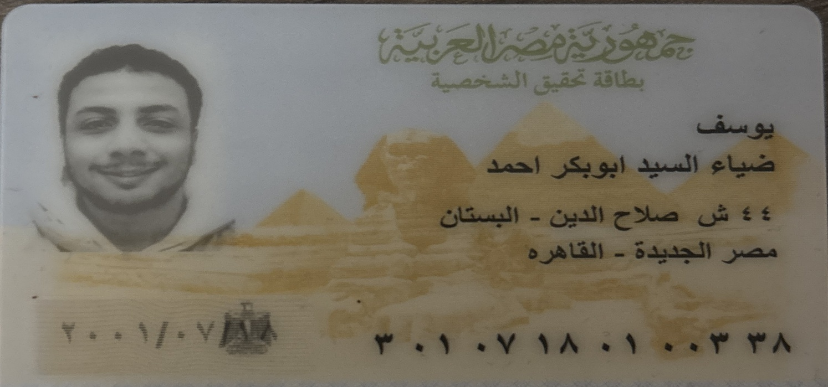**Mobile**: +201022017740